MINOR PROJECT REPORT

SUBMITTED TO



Guru Gobind Singh Indraprastha University

Sector - 16C, Dwarka, Delhi - 110078

*REVZ*

Submitted in partial fulfillment of the requirements for the award of the

degree of

Bachelor of Computer Applications

Submitted to: Submitted by:

Dr. Shalini Bhartiya Prashant Rana

Assistant Professor 13117702022

VSIT VIPS

INDEX

|  |  |  |
| --- | --- | --- |
| S. NO | TOPIC | PAGE NO. |
| 1. | Acknowledgement | 3 |
| 2. | Certificates | 4 |
| 3. | Synopsis of the Project | 6 |
| 4. | Main Report | 9 |
| 5. | Screenshots of Project | 35 |
| 6. | Code | 38 |
| 7. | Conclusion and Future Scope | 48 |
| 8. | References | 51 |

ACKNOWLEDGEMENT

We extend our heartfelt gratitude to the creators and developers of the REVZ website, whose innovation and dedication have made our project possible. Special thanks to the team behind the website for their commitment to providing a user-friendly and efficient tool for a bike helpline service that stays active 24*7 to help users in emergencies as well as making their daily lives easier. Your contribution has been invaluable to our project's success. We also thank our instructors and mentors for their guidance and support throughout this endeavor.

CERTIFICATE

This is to certify that this project entitled “REVZ” submitted in partial fulfillment of the degree of Bachelor of Computer Applications to the DR. SHALINI BHARTIYA through xxxxxxx done by Mr. PRASHANT RANA, RollNo. 13117702022 is an authentic work carried out by him/her at ________ under my guidance. The matter embodied in this project work has not been submitted earlier for award of any degree to the best of my knowledge and belief.

Signature of the student Signature of the Guide

SELF CERTIFICATE

This is to certify that the dissertation/project report entitled “REVZ” is done by me is an authentic work carried out for the partial fulfillment of the requirements for the award of the degree of Bachelor of Computer Applications under the guidance of DR. SHALINI BHARTIYA. The matter embodied in this project work has not been submitted earlier for award of any degree or diploma to the best of my knowledge and belief.

Prashant Rana

13117702022

SYNOPSIS OF THE PROJECT

Revz - Your Trusted 24/7 Bike Helpline Service

Introduction

Revz is an all-inclusive bike helpline service, available 24/7 to ensure peace of mind for bikers facing unexpected issues on the road. Whether it's a flat tire, low battery, lack of fuel, or a mechanical malfunction, Revz is dedicated to connecting bikers to immediate, professional assistance. Our easy-to-use app links users with skilled mechanics nearby, guaranteeing swift response times and dependable service, so that bike owners are never left stranded.

How It Works

Revz is designed for simplicity and speed, enabling bikers to receive assistance in just a few taps:

1. Press the SOS Button: In an emergency, initiate a request by pressing the SOS button in the Revz app.
2. Automatic Mechanic Match: The app finds the nearest available mechanic to ensure quick response.
3. Problem Diagnosis: The mechanic contacts you directly to assess the situation.
4. On-Site Assistance: Once briefed, the mechanic arrives to provide on-the-spot repairs or solutions.

This streamlined approach reduces downtime, helping bikers get back on the road quickly and safely.

Services Offered

Revz offers a comprehensive range of services designed to cover every possible biking emergency:

* Battery and Tyre Assistance: Get help with flat tires or dead batteries, essential for getting back on track.
* Basic Repairs: On-the-spot fixes for minor mechanical issues, eliminating the need for towing.
* Suspension and Wheel Care: Mechanics handle issues with suspension and wheels, ensuring a smooth ride.
* Fuel Delivery: Emergency fuel delivery is available if you run out.
* Insurance Claims: Revz assists with insurance documentation in case of accidents or theft.
* Scheduled Maintenance: Alongside emergency help, Revz offers regular bike servicing, so your bike remains in optimal condition.

Membership Options and Pricing

Revz provides flexible membership plans tailored to the varied needs of bike owners, ensuring services are accessible and affordable. Transparent pricing is a cornerstone of our offerings, with competitive rates and original spare parts used for every repair, making Revz a valuable option for riders across Delhi and beyond.

Coverage Area

Currently operating primarily in Delhi, Revz is expanding its network to cover more regions. With a choice of service location or pickup, users can opt for the most convenient option, whether it's emergency assistance or regular maintenance.

Customer-Centric Features

* 24/7 Availability: Emergencies don’t wait, and neither does Revz – assistance is available anytime, day or night.
* Original Spare Parts: All repairs use high-quality original parts, ensuring lasting durability.
* Affordable Pricing: Our competitive pricing offers excellent value without compromising on quality.
* Customer Testimonials Riders have shared positive experiences, noting Revz's quick response, professionalism, and the sense of security they feel knowing help is always accessible. From swift SOS responses to expert repair services, Revz has earned a reputation as a dependable companion for every biker.

Frequently Asked Questions

* How quickly can Revz reach me? Response times depend on your location, but Revz prioritizes quick assistance.
* What if my bike breaks down in a remote area? Simply press the SOS button – Revz will connect you to the nearest mechanic.
* Can Revz help with a battery jumpstart or fuel delivery? Yes, both services are included in our emergency offerings.
* Does Revz provide regular maintenance? Yes, we also offer periodic bike servicing in addition to emergency support.
* What if I lose my bike keys? Reach out to our support team, who will guide you on the next steps.

Conclusion

Revz stands out as a lifeline for bikers, offering comprehensive solutions for emergencies and regular upkeep. Our commitment to quality, affordability, and customer satisfaction ensures that no biker is ever left stranded. With Revz, help is just a click away, making every journey safer and worry-free.

MAIN REPORT

Objective & Scope of the Project

Objective

The project, "Revz," aims to establish a 24/7 bike helpline service that seamlessly integrates emergency response, on-demand repairs, and preventive maintenance for bikers.

The primary goal is to provide a lifeline for riders facing unforeseen breakdowns, fuel shortages, or mechanical failures, ensuring they have access to immediate, reliable support. By leveraging a streamlined SOS feature and a network of experienced mechanics, Revz aspires to offer an efficient solution for bike-related issues, reducing wait times, minimizing stress, and enhancing safety for bikers.

Through this platform, Revz strives to foster a secure and user-centered experience for motorbike riders, contributing to the broader mission of making biking safer, more accessible, and worry-free.

Establish a Comprehensive 24/7 Bike Helpline Service:

* Create a platform that operates round-the-clock, providing immediate support to bikers in emergencies.
* Ensure continuous availability to address the needs of riders, no matter the time or location.

Integrate Emergency Response with On-Demand Repairs and Preventive Maintenance:

* Offer rapid emergency response for breakdowns, fuel shortages, and mechanical issues.
* Provide on-the-spot repairs and assistance through a skilled network of mechanics.
* Include preventive maintenance services to help riders keep their bikes in optimal condition and avoid breakdowns.

Enhance Biker Safety and Minimize Downtime:

* Reduce wait times by quickly connecting riders to nearby mechanics.
* Minimize stress during emergencies with fast, reliable service and consistent communication.
* Improve road safety for bikers by ensuring they receive help efficiently in potentially hazardous situations.

Build a Seamless, User-Friendly SOS Feature:

* Implement a streamlined SOS feature that enables riders to quickly access assistance with a single tap.
* Automate the process of connecting riders with the nearest available mechanic for quick diagnosis and resolution.

Foster a User-Centered and Secure Experience for Motorbike Riders:

* Prioritize a user-centered design, focusing on simplicity and intuitive functionality for a wide range of users.
* Ensure a secure platform with data privacy measures to protect user information and locations.

Promote Biker Community Safety and Accessibility:

* Work towards making biking, a safer and more accessible mode of transport through reliable assistance.
* Contribute to a biking ecosystem that supports riders’ needs and enhances their confidence on the road.

Establish a Loyal and Satisfied Customer Base:

* Focus on delivering high levels of customer satisfaction through transparency, affordability, and quality.
* Build trust with bikers by providing consistent service quality, transparent pricing, and original spare parts for repairs.

Support Bike Well-Being through Preventive Care:

* Extend services beyond emergency response by offering routine check-ups and preventive maintenance.
* Encourage riders to maintain their bikes with regular servicing, enhancing their vehicles’ longevity and performance.

Position Revz as the Go-To Brand for Biking Support:

* Aim to become a trusted name in biking assistance services within the region.
* Set the foundation for scaling the platform to reach a broader market, positioning Revz as a leading solution in bike support.

Ensure Quality Assurance and Convenience in Every Service Interaction:

* Commit to providing quality repairs and using original spare parts to ensure durability and reliability.
* Focus on convenience through responsive design, real-time updates, and flexible service options, delivering peace of mind to riders.

These objectives position Revz to be more than an emergency helpline; they outline a comprehensive approach to supporting the biking community with a trusted, user-friendly, and dependable service.

Scope

The scope of the Revz project encompasses a comprehensive set of services that cover both immediate response and long-term bike maintenance.

Key areas of scope include:

Emergency Assistance and Real-Time Support:

* Instant SOS Feature: An SOS button within the Revz app will allow bikers to quickly call for help in emergencies. Upon pressing the button, users are instantly connected to the nearest available mechanic, minimizing response time and providing a sense of security.
* On-Demand Mechanic Dispatch: Revz’s network of mechanics is strategically positioned to reach users as quickly as possible, allowing for roadside repairs and quick fixes without requiring towing or prolonged waiting times.
* Diagnostic Communication: Mechanics will contact the rider immediately upon SOS activation to assess the situation remotely, prepare for any necessary tools or parts, and ensure the fastest possible resolution on-site.

Comprehensive Service Offering:

* Battery and Tyre Support: Immediate assistance for dead batteries and flat tires, ensuring that riders can resume their journey without delay.
* Minor Mechanical Repairs: On-the-spot fixes for minor breakdowns or issues such as brake adjustments, chain realignment, and other quick repairs.
* Specialized Suspension and Wheel Care: Expertise in handling mechanical issues related to bike suspension, wheels, and alignment.
* Fuel Delivery Service: For riders stranded due to fuel shortages, Revz offers a fuel delivery service to bring them back on the road without needing to leave their bike behind.

Insurance Claims and Accident Documentation:

* Accident Support Services: In case of accidents or other incidents, Revz helps with documentation, insurance claims, and reporting, alleviating the administrative burden on the biker.
* Guidance on Claim Procedures: Revz will support users through the often-complex insurance claim process, ensuring all necessary steps are covered for efficient reimbursement.

Scheduled and Preventive Maintenance:

* Routine Check-Ups and Scheduled Servicing: Revz provides scheduled maintenance, enabling riders to book periodic services that keep their bikes in top condition, reducing the likelihood of unexpected breakdowns.
* Workshop and Home Pickup Options: Customers can either visit a Revz workshop location or choose home pick-up services, providing flexibility for regular maintenance.
* Use of Genuine Parts for Quality Assurance: Ensuring that all repairs are done with high-quality, original parts to maintain the durability and performance of the bike.

Location-Based Support and Scalability:

* Coverage Expansion: Initially serving Delhi, Revz plans to expand to additional cities and regions, strengthening its network and providing greater accessibility to a broader audience.
* Enhanced Regional Support: The project’s growth roadmap includes establishing partnerships with local workshops, mechanics, and vendors in each location to maintain consistent service quality and coverage.

Affordable and Transparent Pricing Model:

* Transparent Pricing Structure: Revz will offer a clear and easy-to-understand price list for all services, allowing customers to make informed decisions and avoid hidden charges.
* Membership and Subscription Options: The service may include options for subscription plans, where users can receive discounted rates on recurring services, making it a cost-effective choice for frequent riders.

Customer-Centric Platform Design and User Experience:

* User-Friendly Interface: The platform’s design will prioritize simplicity and ease of use, ensuring that riders can access help without complicated navigation or multiple steps.
* Real-Time Tracking and ETA Updates: The app will include real-time tracking of mechanics en route, providing riders with estimated arrival times and reassuring them of the progress.
* Feedback Mechanism: Riders will be encouraged to provide feedback on the quality of service, response times, and overall experience, enabling continuous improvement of services.

Safety, Security, and Quality Assurance:

* Mechanic Vetting and Training: All mechanics in the Revz network will undergo rigorous vetting and training to maintain high standards of professionalism, reliability, and safety for both the mechanics and customers.
* Data Security and Privacy: The platform will ensure that user data, location, and personal information are protected with strict privacy protocols, enhancing user trust and safety.

Community Building and Brand Development:

* Customer Testimonials and Success Stories: By featuring customer success stories, Revz can build trust and strengthen its brand reputation, showcasing real experiences of riders who have benefited from the service.
* Promotional Events and Biker Community Engagement: Revz plans to engage the biking community through events, workshops, and other activities, fostering a loyal community of bikers who rely on Revz for their needs.

Long-Term Vision and Potential for Growth

As Revz establishes itself in the biking assistance market, it will explore further expansions such as partnerships with bike manufacturers, rental services, and tourism companies to offer exclusive benefits. Additionally, Revz may expand its services to cover other two-wheeler or even four-wheeler emergency services, leveraging its platform infrastructure and expertise. Future updates to the platform could include machine learning algorithms to predict maintenance needs, AI-driven diagnostics, and IoT integration with bikes for automated alerts.

By continuously innovating, expanding its service range, and staying attuned to the evolving needs of riders, Revz aims to be more than just an emergency helpline—it envisions becoming an essential partner in the biking experience, providing riders with comprehensive support for every mile they travel.

Theoretical Background Definition of Problem

Theoretical Background

With the growth of urban populations and rising congestion, motorcycles have become a favored mode of transportation due to their affordability, fuel efficiency, and maneuverability. However, this growth has also led to increased demand for reliable maintenance and emergency assistance services specifically tailored to motorbikes. Unlike cars, which benefit from a well-established network of roadside assistance options, bike riders have limited access to similar support, leaving them vulnerable to unexpected breakdowns and roadside emergencies. This lack of specialized support creates a service gap that significantly impacts rider safety, convenience, and overall peace of mind, especially for those who rely on their bikes for daily commutes or long-distance travel.

In urban environments, where riders may encounter issues such as flat tires, battery failures, fuel shortages, or mechanical malfunctions, the lack of immediate and reliable assistance becomes not only a matter of inconvenience but also a potential safety hazard. Existing services often cater primarily to cars, resulting in delayed response times for bike riders who need prompt intervention. In emergency situations, this delay can result in increased exposure to traffic risks, theft, and other hazards, making the need for a dedicated bike assistance platform all the more urgent​(Synopsis for the Website)​(Synopsis for the Website).

Definition of the Problem

The challenges faced by bike riders in emergency and maintenance scenarios can be broadly categorized into the following areas:

* Inadequate Access to Immediate Help: Riders frequently experience a lack of accessible, rapid-response roadside assistance that caters specifically to motorcycles. Existing options are often designed for cars, and the limited services available for bikes do not ensure prompt response times. This delay in service, coupled with the vulnerability of being stranded on the roadside, makes emergency situations particularly stressful and dangerous for bikers. With more two-wheelers on the road than ever before, this gap affects a substantial portion of urban commuters, yet there is a clear lack of specialized services to meet this demand​(revz)​(Synopsis for the Website).
* Inconvenience and Practicality Issues with Traditional Repair Options: Traditional repair services typically require bikers to physically transport their vehicles to a workshop, which may be far from the site of the breakdown. This logistical barrier makes it difficult for riders to receive timely help, particularly when their bike is immobilized. Many of these workshops also lack standardization in pricing and service quality, resulting in inconsistent customer experiences. Riders may have to rely on informal roadside mechanics whose service standards and parts quality may be subpar, risking the reliability and safety of their bikes over time​(Synopsis for the Website)​(revz).
* Limited Range of Emergency Services for Motorcycles: Bike-specific emergencies often include unique needs such as tire repairs, battery jumpstarts, fuel delivery, and on-the-spot mechanical adjustments. However, most available services are not equipped to handle these requirements, especially for motorcycles, leaving bikers with limited or inadequate options. Many existing services lack the tools and expertise necessary for quick fixes, increasing the likelihood of prolonged downtime and safety risks for riders. The demand for services that can provide comprehensive, bike-specific emergency support has largely gone unmet, highlighting a pressing need for a more focused and capable solution​(Synopsis for the Website).
* Challenges in Navigating Insurance and Accident Documentation: In the event of an accident, riders often need guidance through the insurance claims process, which involves detailed documentation and communication with insurers. Many riders find this process overwhelming, particularly when combined with the stress of an accident or breakdown. Without professional assistance, navigating the steps required for efficient claims and documentation can lead to delays in reimbursement or repair approvals. This aspect of post-accident support is rarely addressed in the existing service landscape, leaving a significant gap in the continuum of assistance that riders need during crisis situations​(revz).

Need for a Comprehensive, Bike-Specific Solution

To bridge the gap in roadside assistance and maintenance for motorcycle riders, there is a clear need for a platform that offers dedicated, reliable, and swift support for biking emergencies. This solution must cater specifically to the needs of motorbike owners, providing rapid response times, expert mechanical help, and a range of bike-focused services that can be accessed with minimal delay. The ideal service would incorporate:

* A Rapid-Response System for Emergencies: A platform that features a one-click SOS button, connecting riders with the nearest available mechanic for real-time assistance. This functionality would not only provide immediate relief to stranded riders but also foster a sense of security by assuring them that help is accessible with minimal effort, regardless of their location.
* On-Demand Mechanic Dispatch with Real-Time Tracking: An efficient mechanic dispatch system equipped with location tracking could provide real-time updates, allowing riders to monitor the mechanic’s arrival. This transparency would enhance the user experience, reassuring riders and reducing the anxiety of waiting alone by the roadside.
* Comprehensive Service Portfolio Tailored to Bikes: The service should cover a wide range of common biking emergencies, including tire repairs, battery jumpstarts, fuel delivery, and on-site repairs for minor mechanical issues. By offering specialized support designed specifically for bikes, this solution would effectively address the unique demands of motorbike emergencies.
* Insurance and Documentation Assistance: The platform could include resources and guidance for navigating insurance claims and documentation requirements, reducing the burden on riders following accidents. This added layer of support would not only streamline the claims process but also position the platform as a full-service solution for all aspects of bike-related crisis management.
* Routine Maintenance and Preventive Care Options: In addition to emergency services, the platform could offer scheduled maintenance and preventive care services to keep bikes in optimal condition, minimizing the risk of breakdowns. Features such as home pick-up and drop-off for routine maintenance could add further convenience, making it easier for riders to stay proactive about bike care.
* Transparent Pricing and Quality Assurance: Pricing transparency, along with the use of genuine spare parts, would address concerns about affordability and reliability. This aspect would build trust and loyalty among customers, establishing the platform as a trusted partner in their biking experience.

The Solution: Revz - A Dedicated Platform for Bikers

Revz seeks to fulfill this need by creating a dedicated 24/7 bike assistance platform that combines emergency support, on-demand mechanical help, and preventive maintenance services. Through a user-friendly app, bikers can quickly access a range of services by pressing an SOS button that connects them with the nearest available mechanic. This prompt response mechanism, coupled with real-time tracking, ensures riders know help is on the way, minimizing wait times and offering reassurance during distressing situations.

Additionally, Revz offers specialized services for tire and battery issues, fuel delivery, minor mechanical repairs, and assistance with insurance claims and documentation, making it a holistic solution for riders. By focusing on transparent pricing, quality assurance, and customer-centered design, Revz aims to address the unique challenges faced by bikers, enhancing their safety and convenience on the road.

Revz also envisions a future where it expands regionally and integrates additional features like membership plans, predictive maintenance alerts, and potential partnerships with bike manufacturers. This comprehensive approach allows Revz to position itself not only as an emergency helpline but also as a reliable partner in the maintenance and upkeep of bikes, building a long-term relationship with its users and becoming a trusted name in the biking community.

In summary, Revz is designed to fill a critical gap in the current landscape of roadside assistance by focusing on the distinct needs of bike riders, providing a seamless, dependable, and bike-specific solution that enhances the overall biking experience.

System Analysis & Design vis-a-vis User Requirements

System Analysis

The development of Revz, a 24/7 bike helpline service, requires an in-depth analysis to understand the demand for such a platform, identify key factors driving its necessity, and highlight the potential benefits it can bring to the market. This analysis study examines several aspects of the project, including market demand, competitor landscape, user needs, service feasibility, and projected impact.

1. Market Demand Analysis

The number of motorbikes on the road has increased significantly in urban areas, where bikes are a preferred mode of transport due to their affordability, fuel efficiency, and ease of navigation in heavy traffic. Despite this, the current roadside assistance market lacks dedicated services for bikers, leaving a large segment of riders underserved. Traditional roadside assistance services primarily cater to cars, with limited support for two-wheelers.

According to recent studies and market research on the automotive assistance industry, there is a growing need for services that specifically target the two-wheeler segment, particularly in densely populated urban areas and regions where bikes are a primary form of transportation. This gap presents a strong market opportunity for a service like Revz, which can cater directly to the emergency and maintenance needs of bike owners. A service that is bike-specific, affordable, and available 24/7 is expected to attract a substantial customer base from urban commuters, delivery drivers, and long-distance bikers alike.

2. Competitive Landscape

The roadside assistance market for two-wheelers remains largely untapped, with limited players providing specialized, dedicated services for motorbikes. Current roadside assistance services are heavily focused on car owners, offering minimal support for bikes or none at all. Additionally, many existing options lack the infrastructure to provide rapid-response services specifically designed for bikes, such as tire repair, battery assistance, and fuel delivery.

Existing competitors often include informal roadside mechanics or workshops with inconsistent service quality, lack of pricing transparency, and limited availability in remote or high-demand areas. By offering a bike-specific platform with consistent service quality, transparent pricing, and a streamlined process, Revz can effectively differentiate itself. Furthermore, Revz’s commitment to using original spare parts and trained mechanics positions it as a higher-quality, more reliable alternative to informal repair options.

3. User Needs and Pain Points

Analysis of the common pain points experienced by bikers reveals several recurring issues that indicate a strong need for the Revz platform:

* Lack of Immediate Assistance in Emergencies: Bikers often face long wait times when stranded, as existing services prioritize cars. This issue highlights the need for a quick, reliable solution that can connect bikers with the nearest mechanic or provide immediate roadside assistance.
* Inconsistent Service Quality and Transparency: Many riders are dissatisfied with the unpredictable service quality and lack of clear pricing among traditional roadside repair options. Revz can address these concerns by ensuring transparency, affordability, and quality control across all service offerings.
* Difficulty in Navigating Insurance Claims: Riders involved in accidents often require guidance through complex insurance claims. Revz’s support with insurance documentation can streamline this process, making it easier for riders to handle post-accident formalities.
* Limited Preventive Maintenance Options: Bikers are increasingly seeking preventive maintenance options to avoid emergency situations altogether. By offering scheduled maintenance and repair services, Revz can fulfill this growing demand and build long-term customer relationships.

This analysis indicates that the Revz platform’s core offerings—rapid-response emergency assistance, quality-controlled repairs, transparent pricing, and preventive maintenance—directly address the primary needs of bike riders, creating a user-centered solution for an underserved market.

4. Service Feasibility and Operational Requirements

To ensure operational feasibility, Revz requires a network of trained mechanics, strategically located to provide rapid-response services across high-demand regions. This network will enable the platform to fulfill SOS requests in minimal time, delivering reliable and high-quality support in emergency situations. Key operational components include:

* Mechanic Training and Quality Assurance: All mechanics within the Revz network will undergo rigorous training to uphold service standards, ensuring consistency and professionalism across all interactions. Standardized processes for common repairs and emergency services will be implemented to maintain high service quality.
* Platform Development and Infrastructure: A user-friendly app with real-time tracking, location-based services, and a streamlined SOS button will facilitate easy access for riders in distress. Additionally, the platform must be able to handle high volumes of simultaneous requests and support a range of payment options, from one-time payments to subscription models.
* Inventory of Genuine Parts: The use of original, high-quality spare parts will be integral to Revz’s value proposition. Partnering with reliable suppliers for genuine parts will ensure repairs are durable and maintain the safety and performance of customers’ bikes.

By building a strong operational foundation and leveraging technology for real-time coordination, Revz can provide a seamless, reliable experience for its users.

5. Projected Market Impact and Benefits

The introduction of Revz is anticipated to create a positive impact on both bikers and the broader community, contributing to safer, more reliable transport for individuals and commercial riders alike. Key projected impacts include:

* Increased Safety for Riders: By providing immediate assistance during breakdowns and emergencies, Revz enhances the safety of riders, particularly in high-risk or remote areas where the likelihood of receiving help is otherwise low. This added layer of security can help mitigate potential accidents or vulnerabilities associated with being stranded.
* Reduction in Unplanned Downtime: With access to a dependable roadside service, riders can avoid prolonged wait times, helping them get back on the road faster. This feature will be particularly beneficial for commercial bikers, such as delivery drivers, who rely on minimal downtime to meet professional commitments.
* Cost Savings through Preventive Maintenance: By offering preventive maintenance services, Revz can help users avoid costly repairs that arise from deferred maintenance or emergency fixes. Regular upkeep will also extend the lifespan of bikes, reducing long-term ownership costs for riders.
* Job Creation in the Mechanic Network: The Revz platform will require a robust network of skilled mechanics, potentially creating employment opportunities and enhancing skills within the community. Mechanic training programs and quality standards set by Revz will contribute to higher service quality and skill development for mechanics.
* Enhanced Customer Trust and Brand Loyalty: By focusing on transparency, quality assurance, and customer satisfaction, Revz aims to build a trusted brand in the bike assistance market. As customers experience consistent service quality and reliability, they are likely to develop brand loyalty, which will benefit Revz in terms of sustained user engagement and referral growth.

6. Financial Viability and Revenue Streams

Revz’s financial viability rests on a diverse revenue model that includes:

* Pay-Per-Use Fees for Emergency Services: Riders can pay a one-time fee for emergency services, offering flexibility for those who require occasional assistance.
* Subscription Plans for Regular Maintenance and Discounts: Revz can introduce subscription packages that provide users with routine maintenance, discounted rates on emergency services, and exclusive benefits, incentivizing long-term membership.
* Partnering with Bike Manufacturers and Insurance Companies: Collaborations with bike manufacturers or insurance companies could provide bundled services, giving Revz access to a larger customer base and additional revenue streams.
* In-App Advertising and Sponsored Partnerships: The app can feature relevant advertisements from partners in the automotive, accessories, or insurance industries, adding a supplementary revenue stream while maintaining a user-friendly experience.

7. Potential Challenges and Risk Mitigation

Potential risks associated with the implementation of Revz include:

* Maintaining Response Times: As demand grows, maintaining rapid response times across locations will be essential. To address this, Revz can employ dynamic routing algorithms to optimize mechanic dispatch and consider expanding its mechanic network in areas with high demand.
* Service Quality Consistency: Ensuring that all mechanics deliver high-quality service may be challenging as the network grows. Revz can mitigate this risk through continuous training, quality checks, and user feedback mechanisms.
* Market Penetration and Customer Acquisition: As a new entrant, Revz will need to invest in marketing to build brand awareness and attract users. To overcome this challenge, Revz can leverage digital marketing strategies, customer referral programs, and partnerships to reach a larger audience quickly.

Conclusion

The analysis study highlights a significant opportunity for Revz to fill a service gap in the roadside assistance market for motorbikes. By addressing the specific needs of bike riders and offering a dedicated platform for emergency help, preventive maintenance, and insurance support, Revz is well-positioned to establish itself as a leader in bike assistance services. Through a combination of customer-centered features, quality assurance, and operational scalability, Revz has the potential to create a lasting impact, promoting rider safety, convenience, and satisfaction across urban regions and beyond.

Design vis-a-vis User Requirements

Enhanced Emergency SOS Feature:

* One-click SOS button with an automatic location detection and direct connection to nearby mechanics.
* Option to provide details on the type of issue (e.g., flat tire, engine problem) for faster resolution.
* In-app messaging with the mechanic while waiting for service arrival.
* Ability to set preferred response time (e.g., “Urgent” or “Within the hour”) for non-critical issues.

Advanced Location Tracking and Mechanic Dispatch:

* GPS integration for precise location tracking and real-time location updates on the mechanic’s progress.
* Interactive map displaying nearby mechanics and service options, with estimated arrival times for each.
* Ability to share location with friends or family for additional safety until assistance arrives.
* Option to track routes and view a live estimated arrival time (ETA) countdown.

Service Request and Appointment Scheduling with Customization:

* Flexibility to choose between emergency and scheduled services, with options to add notes or specific requests.
* Detailed service selection including options like “Engine diagnostics,” “Oil change,” “Brake check.”
* Scheduling options with reminders for periodic maintenance (e.g., monthly, quarterly).
* Choice of service mode: on-site repair, workshop visit, or home pickup and delivery for more convenience.

Expanded Range of Bike-Specific Services:

* Coverage of essential services including puncture repair, battery replacement, brake adjustment, chain tightening, and clutch repair.
* Options for advanced mechanical checks (e.g., suspension inspection, exhaust system repair).
* Preventive services such as full diagnostic checks, oil and fluid top-ups, and tire pressure adjustments.
* Cleaning and detailing services for maintenance of bike aesthetics and performance (e.g., bike spa, rust removal).

Comprehensive Payment Options and Transparent Pricing:

* Itemized service pricing visible before service confirmation, including estimated labor and part costs.
* In-app secure payment integration supporting various methods (credit/debit, UPI, digital wallets).
* Option to store payment details securely for quick future transactions.
* Split payment option for group or joint rides, where multiple riders contribute to a single service bill.

Subscription Plans, Membership Options, and Loyalty Programs:

* Monthly, quarterly, and annual subscription models offering exclusive benefits (e.g., free on-site repairs, discounted rates).
* Membership tiers (e.g., Silver, Gold, Platinum) with varying levels of perks, such as priority service or extended warranty on parts.
* Rewards and loyalty points system to encourage repeat usage, redeemable for discounts or complimentary services.
* Ability to gift membership plans or loyalty points to friends or family.

User-Friendly Interface with Personalized Dashboard:

* Customized dashboard with real-time updates on active requests, upcoming appointments, and service history.
* Ability to save preferred services for quick access and add frequently used addresses for easy service requests.
* Accessible design with voice command support and easy navigation for riders on the go.
* Support for dark mode and customizable themes to reduce glare and enhance visibility in different lighting conditions.

Insurance Assistance and Accident Documentation Support:

* In-app prompts guiding users through the process of documenting accidents (e.g., photo upload, notes).
* Direct support for insurance claim submission, including an option to share incident details with insurance companies.
* Digital storage of all relevant insurance paperwork and prior claims for easy retrieval.
* Assistance with arranging temporary transportation options if the bike is taken for extended repairs.

Detailed Feedback and Rating System with Incentives:

* Enhanced feedback options allowing riders to rate the mechanic on punctuality, service quality, and professionalism.
* Detailed review section enabling users to leave suggestions or comments for service improvement.
* Ratings system for mechanics to help users make informed choices based on past experiences.
* Incentives for users who leave feedback (e.g., small discounts on future services or loyalty points).

Comprehensive Notifications, Alerts, and Reminders:

* Push notifications for service milestones, such as mechanic dispatch, en route updates, and arrival.
* Reminders for scheduled maintenance services, insurance renewals, and warranty expirations.
* Customizable alert settings to control frequency and type of notifications (e.g., important updates only, all notifications).
* Alerts for weather or traffic conditions affecting arrival times and recommendations for nearby safe spots to wait.

Safety and Privacy Enhancements:

* Advanced data encryption for user data, location, and payment information.
* Option to enable two-factor authentication (2FA) for added account security.
* Emergency contact sharing for prolonged breakdown situations, allowing trusted individuals to stay informed.
* In-app access to safety guidelines and steps for maintaining safety while waiting for roadside assistance.

Real-Time Customer Support and Live Chat Assistance:

* 24/7 in-app live chat support for instant help with service inquiries or app issues.
* Detailed FAQ section, user guide, and video tutorials to help users navigate the app and understand services.
* Dedicated support for subscription and membership inquiries, providing answers to account and billing questions.
* Call-back option for voice support when users prefer speaking with a customer representative.

History, Service Records, and Maintenance Log:

* Comprehensive records of all past services, including details of parts replaced and costs incurred.
* Option to download or email service records for insurance or personal records.
* A maintenance log with reminders based on the last service date and upcoming suggested maintenance.
* Ability to categorize and filter service history (e.g., emergency vs. scheduled, repairs vs. maintenance).

Integration with Biker Community and Social Features:

* Community forum for riders to share tips, recommendations, and experiences with the Revz platform.
* Social media sharing options to allow users to recommend services or promote positive experiences.
* Group ride planning and service sharing features, enabling coordination for rides and group assistance bookings.
* Rewards for users who refer friends to the platform, with referral credits or loyalty points.

In-App Advertising and Sponsored Content:

* Non-intrusive display of relevant promotions from bike accessory brands, insurance providers, and related businesses.
* User option to disable ads or select ad preferences for a more personalized experience.
* Sponsored content aligned with bike maintenance, safety gear, and biking events for enhanced user engagement.

Enhanced Analytics and Service Optimization:

* Performance analytics and reporting for users to track spending on maintenance and repair trends.
* Insights into bike health based on service history, with predictive maintenance suggestions.
* Machine learning integration to optimize service recommendations based on user behavior and feedback.

Expansion Features for Additional Vehicle Types (Future Planning):

* Adaptability of services to include other two-wheelers (e.g., scooters, mopeds) and possibly four-wheelers for expanded market reach.
* User option to add multiple vehicles under one account, with distinct maintenance logs for each vehicle.
* A customized service for different types of vehicles as the platform expands.

Integration with IoT and Connected Devices (Long-Term Vision):

* Support for connected bike features, including real-time diagnostics, alerts for maintenance needs, and live tracking.
* Compatibility with smart helmets or devices that allow hands-free SOS activation and direct communication with mechanics.
* Integration with IoT-enabled parts to monitor component health (e.g., battery, tire pressure sensors).

These user requirements aim to provide a fully-featured, user-centric platform that covers all aspects of bike assistance, from immediate roadside help to long-term maintenance planning and community engagement. Revz is designed to meet the growing needs of bike riders, creating a reliable and convenient support system that enhances the safety, convenience, and overall biking experience.

System Planning (PERTChart)

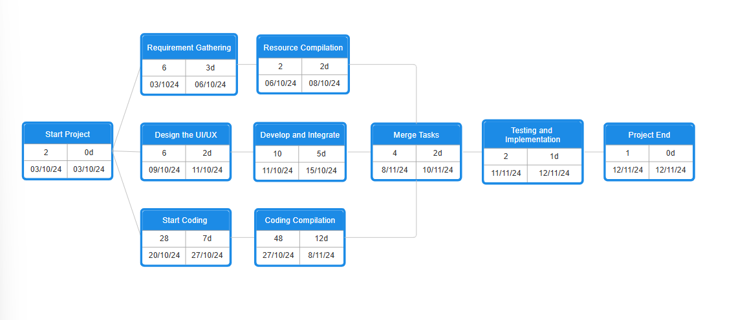

Below is a short description of every stage:

* Start Project: Commences on 03-10-24 and duration is 0 days.
* Requirement Gathering: This step starts on 03-10-24 to 06-10-24 of the project timeline as it seeks to determine the requirements for the project.
* Resource Compilation: It commences immediately after the requirement gathering on 06-10-24 and lasts for 2 days to end on 08-10-24.
* Design the UI/UX: Runs from 09-10-24 and ends by 11-10-24 with total duration of 2 days. This phase includes designing the user interface and experience.
* Develop and Integrate: Performs the function of developing, which begins at 11-10-24 and ending at 15-10-24.
* Start Coding: Winters phase of the project occurring on 20-10-24 and ending on 27-10-24 set for a duration of seven days.
* Coding Compilation: Set to run from 27-10-24, this phase has duration of 12 days and is expected to end by 08-11-24. It encompasses code compilation and code testing.
* Merge Tasks: Though this procedure is set to run from 08-11-24 to 10-11-24, only half a day would be required to perform the functions.
* Testing and Implementation: Lastly, this phase involves the testing and finalization of the project, and only one day is required to carry out this procedure.
* Project End: This marks the closes of all issues pertaining to the project.

The dependencies between the phases are visible in the timeline aidering it the workflow leading to the project’s finish on 12/11/24.

Methodology adopted, System Implementation & Details of Hardware & Software used, System Maintenance &Evaluation

Methodology Adopted

The website design and development process likely followed a combination of planning, design, coding, testing, and deployment phases:

1. Planning: Defined the purpose (bike service platform), target audience (bike owners in Delhi), and core features (service information, SOS button, membership options).
2. Design: Created a layout using wireframes and decided on a color scheme and typography that is appealing and functional. The layout likely prioritized ease of navigation and accessibility.
3. Development: Used HTML for structure, CSS for styling, and JavaScript for interactivity.
4. Testing: Ensured cross-browser compatibility, checked for responsiveness on various devices, and tested the functionality of interactive elements like the SOS button.
5. Deployment: Deployed on a web server, ensuring that all features work as intended in the live environment.

System Implementation

A breakdown of the front-end implementation:

HTML: Used for structuring the content. Key elements likely include:

* Navigation bar with links to "Home," "Membership," and "Try Free"
* Main content section for "Bike Service In Delhi" description
* An SOS button for emergency support

CSS: Used to style the website, making it visually appealing. The design likely includes:

* A grayscale image as the background for an aesthetic look.
* Bold typography for the main headline and subheading.
* A consistent color scheme, with yellow used prominently for elements like the logo and SOS button.
* Responsive styling to ensure usability across different screen sizes.

JavaScript: Likely used for interactivity, especially:

* The SOS button, which might trigger a specific action (like dialing a number or showing emergency contacts).
* Any dynamic features like pop-ups or real-time updates.

Details of Hardware & Software used

Hardware Requirements:

Basic system requirements would include a computer with a modern browser (e.g., Chrome, Firefox) and a testing device (e.g., smartphone or tablet) for responsiveness testing.

Software & Tools Used:

* Code Editor: Visual Studio Code, Atom, or Sublime Text for coding HTML, CSS, and JavaScript.
* Browser Developer Tools: For debugging and inspecting HTML/CSS.
* Version Control: Git for version management.
* Design Tools (optional): Tools like Figma or Adobe XD for initial mock-ups.

System Maintenance and Evaluation

System Maintenance

A comprehensive maintenance plan is essential to keep the system operational, up-to-date, and secure over time. Here’s an expanded look at maintenance strategies:

1. Software and Framework Updates

* Frequent Codebase Review: As HTML, CSS, and JavaScript evolve, certain syntax and functions may become deprecated. Reviewing and refactoring the codebase periodically ensures compatibility with newer web standards.
* Progressive Enhancement: When introducing new features or upgrades, maintain compatibility for older browsers and devices. This can be achieved by implementing progressive enhancement techniques that allow the site to function well even with limited browser support.

2. Bug Tracking and Issue Resolution

* User-Focused Debugging: Regularly monitor logs and gather user feedback to identify areas where users experience problems. Addressing these issues promptly ensures a smooth and satisfying user experience.
* Continuous Integration and Deployment (CI/CD): A CI/CD pipeline allows for rapid deployment of fixes, features, and updates. By automating testing and deployment, new code can be released without interrupting service.

3. System Monitoring and Analytics

* Comprehensive Analytics: Beyond tracking page views and user clicks, use analytics tools to monitor user paths, dropout points, and conversions. Understanding user behavior can provide insights into areas that may need improvement or optimization.
* Usage Analysis of SOS Feature: Monitor metrics specific to the SOS feature, such as average response time, time taken for mechanic arrival, and user feedback. This analysis helps to identify bottlenecks and areas for improvement, ensuring users receive quick and efficient service.

4. Regular Security Audits

* Penetration Testing: Conduct regular penetration testing to identify vulnerabilities and simulate real-world attacks. This can uncover weak spots in security and give the team insights into possible exploits.
* GDPR and Compliance Checks: Regular audits ensure compliance with data protection laws like GDPR or CCPA. Implement data minimization techniques to only collect essential information and provide clear privacy notices to users.

5. Data Management and Database Optimization

* Indexing and Query Optimization: Regularly optimize database queries to enhance performance. Indexing frequently accessed data can speed up retrieval times, which is especially useful for the SOS feature.
* Automated Data Purging: Implement an automated system to purge outdated data, like completed service requests or old location data, to keep the database efficient. This improves response times and reduces storage costs.
* Backup and Recovery Testing: Regularly test the data backup and recovery process to ensure reliability. Backups should be stored securely and tested to confirm they can restore data accurately in the event of data loss.

Evaluation

* Design: Clean and straightforward layout with a monochromatic theme. Good choice of colors for readability and branding.
* Usability: Easy-to-navigate structure with visible SOS button; appropriate for emergency services.
* Responsiveness: Assumed responsive design based on your use of HTML and CSS.
* Functionality: Key functions like navigation, SOS button, and page layout seem well-executed. More details on the SOS button’s functionality would provide further insights.

Detailed Life Cycle of the Project

ERD

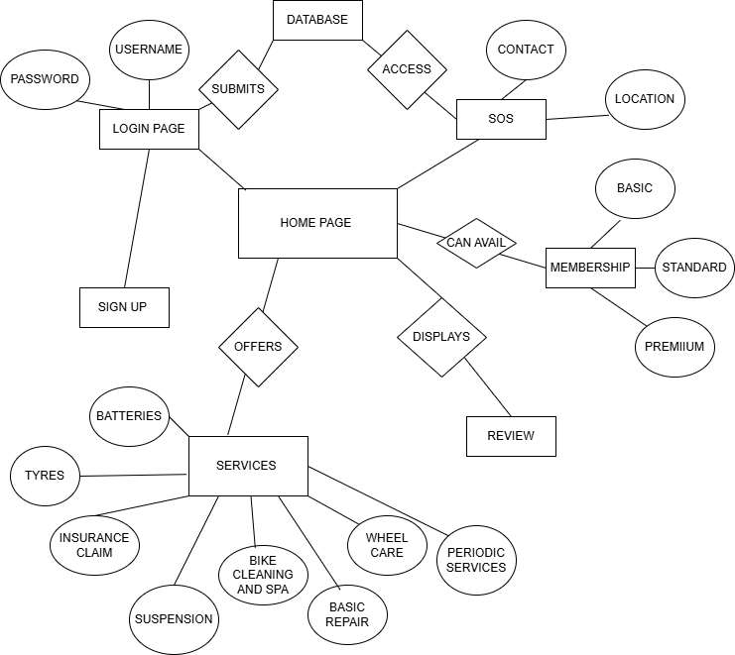

DFD

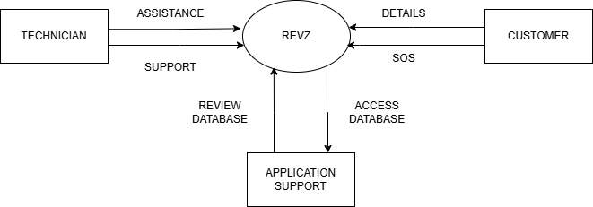

SCREENSHOTS OF THE PROJECT

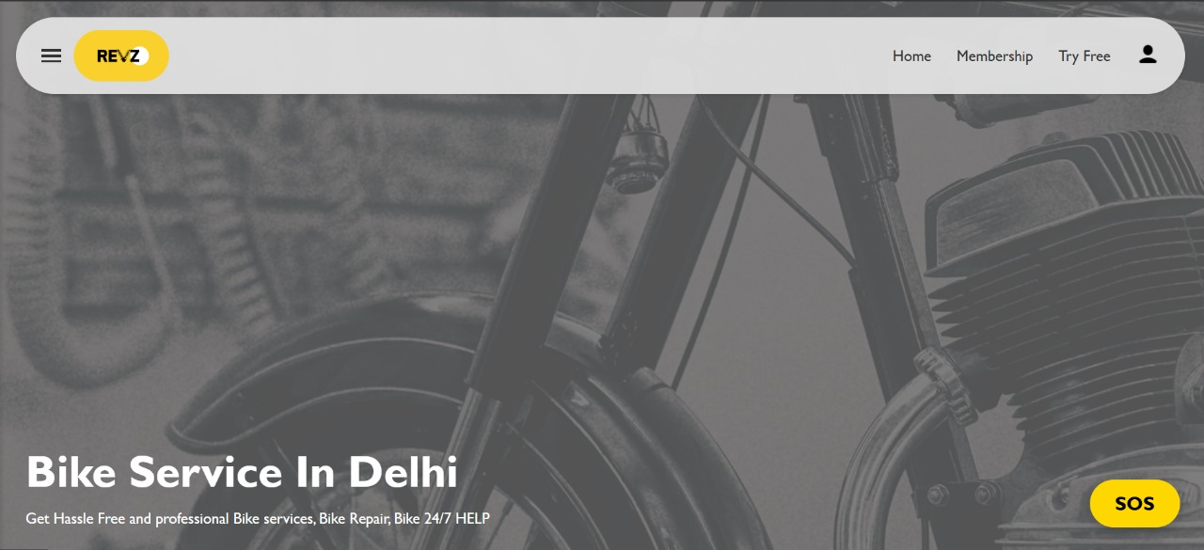

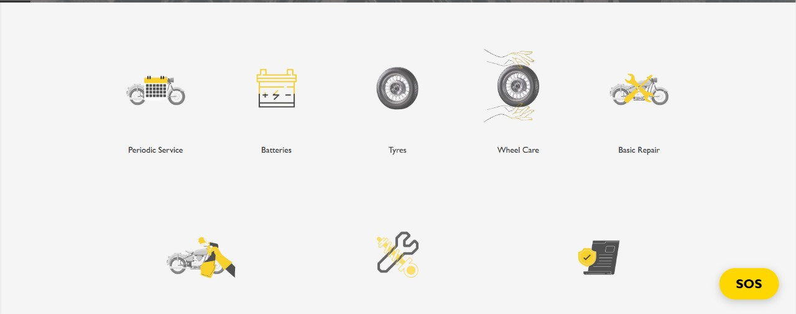

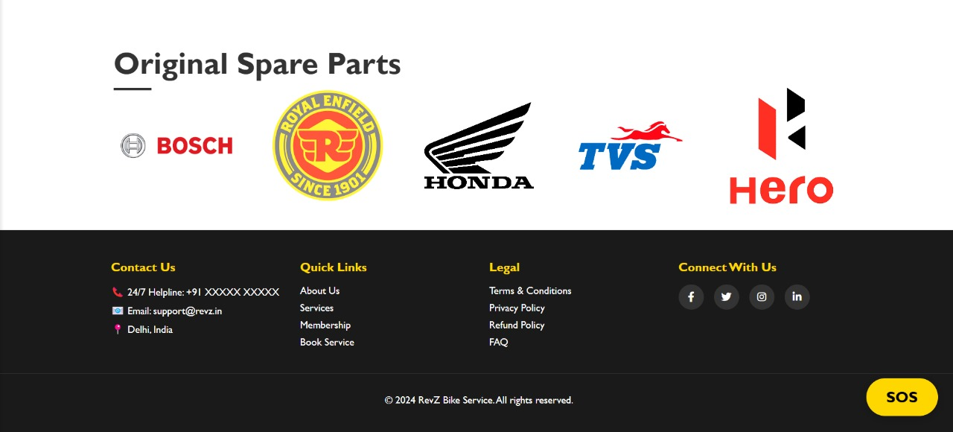

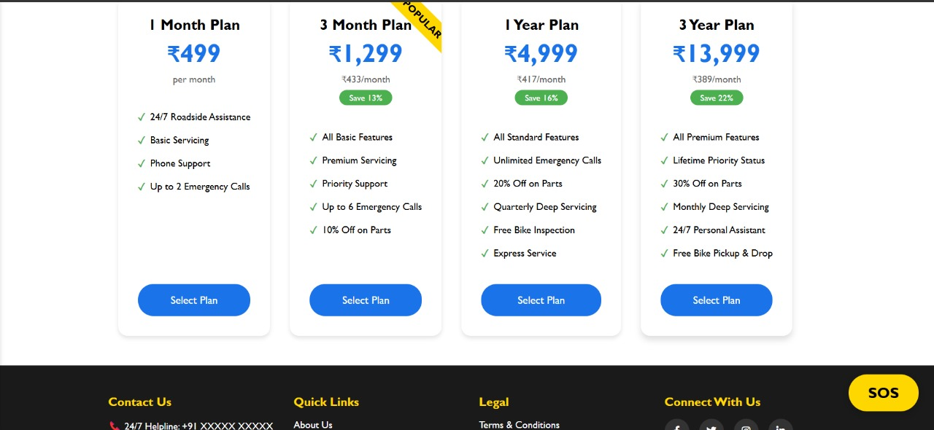

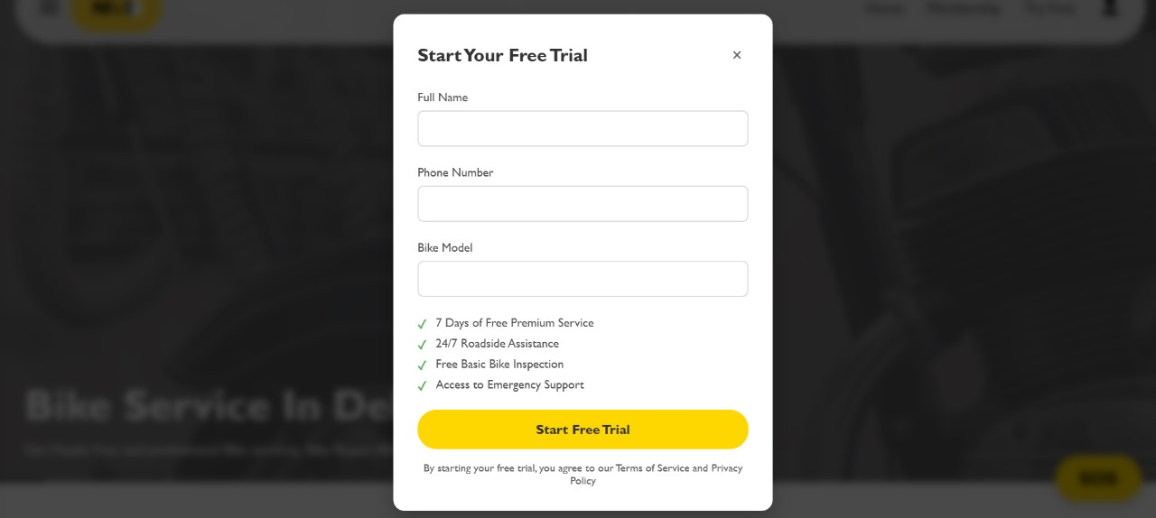

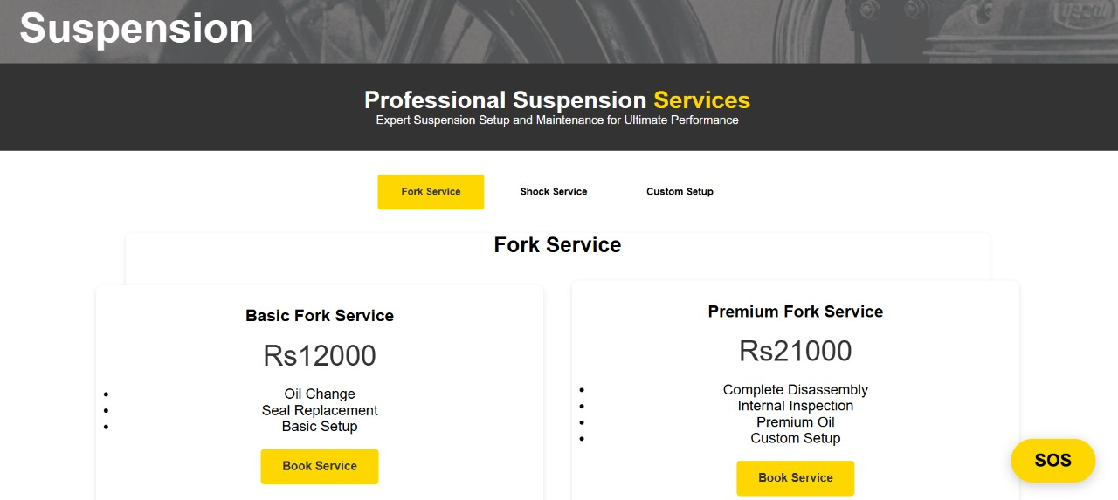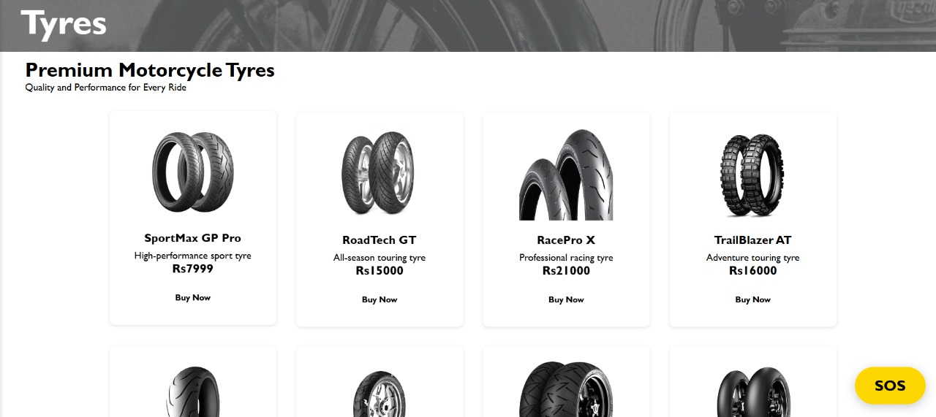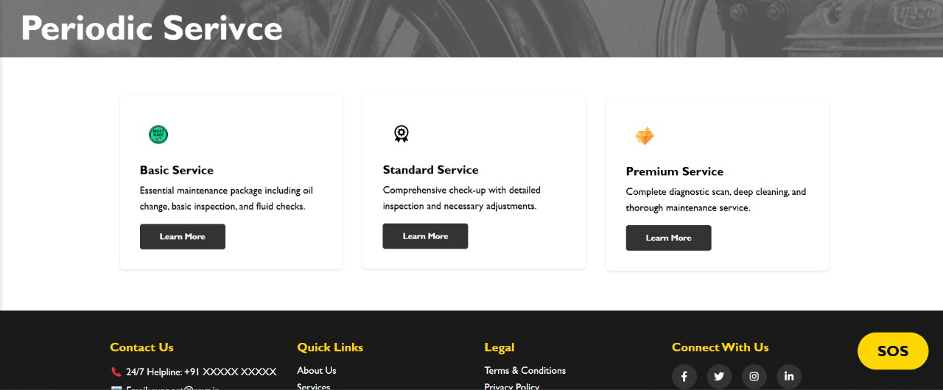

CODE

<!DOCTYPE html>

<html lang="en">

<head>

<meta charset="UTF-8">

<meta name="viewport" content="width=device-width, initial-scale=1.0">

<title>RevZ</title>

<link rel="stylesheet" href="CSS/home.css">

<link rel="stylesheet" href="CSS/login_signup.css">

</head>

<body>

<!-- Previous navbar code remains the same -->

<nav class="navbar">

<div class="nav-left">

<div class="menu-icon" id="menuIcon">

<div class="bar"></div>

<div class="bar"></div>

<div class="bar"></div>

</div>

<div class="logo"><img src="images/Re.png" alt="" class="logo"></div>

</div>

<div class="nav-right">

<a href="index.html">Home</a>

<a href="memberships.html">Membership</a>

<a href="#tryFreeLink" id="tryFreeLink">Try Free</a>

<!-- <div class="profile-icon" onclick="toggleSidebar()"><img src="images/icons8-user-30.png" alt="👤"

class="profile-icon"></div>

</div> -->

<div class="profile-dropdown">

<button onclick="toggleDropdown()" class="profile-icon"><img src="images/icons8-user-30.png" alt=""></button>

<div id="dropdownMenu" class="dropdown-content">

<a href="#">My Profile</a>

<a href="" onclick="event.preventDefault(); showLoginPane()">Sign In</a>

<a href="" onclick="event.preventDefault(); showSignupPane()">Sign Up</a>

<a href="#">Logout</a>

</div>

</div>

</nav>

<!-- trials section -->

<div class="modal-overlay" id="modalOverlay"></div>

<div class="modal" id="tryFreeModal">

<div class="modal-header">

<h2 class="modal-title">Start Your Free Trial</h2>

<button class="close-modal" id="closeModal">&times;</button>

</div>

<form id="trialForm">

<div class="form-group">

<label class="form-label" for="name">Full Name</label>

<input type="text" id="name" class="form-input" required>

<div class="error-message" id="nameError">Please enter your full name</div>

</div>

<div class="form-group">

<label class="form-label" for="phone">Phone Number</label>

<input type="tel" id="phone" class="form-input" required>

<div class="error-message" id="phoneError">Please enter a valid phone number</div>

</div>

<div class="form-group">

<label class="form-label" for="bikeModel">Bike Model</label>

<input type="text" id="bikeModel" class="form-input" required>

<div class="error-message" id="bikeError">Please enter your bike model</div>

</div>

<ul class="benefits-list">

<li>7 Days of Free Premium Service</li>

<li>24/7 Roadside Assistance</li>

<li>Free Basic Bike Inspection</li>

<li>Access to Emergency Support</li>

</ul>

<button type="submit" class="submit-btn">Start Free Trial</button>

<p class="trial-terms">

By starting your free trial, you agree to our Terms of Service and Privacy Policy

</p>

</form>

</div>

<!-- login and signup -->

<div class="model" id="loginPane">

<div class="model-content">

<span class="close" onclick="closeModel('loginPane')">&times;</span>

<h2>Login</h2>

<form id="loginForm">

<input type="text" id="loginUsername" placeholder="Username" required>

<input type="password" id="loginPassword" placeholder="Password" required>

<button type="submit">Login</button>

</form>

<p class="switch" onclick="showSignupPane()">Don't have an account? Sign up</p>

</div>

</div>

<!-- Signup Pane -->

<div class="model" id="signupPane">

<div class="model-content">

<span class="close" onclick="closeModel('signupPane')">&times;</span>

<h2>Sign Up</h2>

<form id="signupForm">

<input type="text" id="signupUsername" placeholder="Username" required>

<input type="email" id="signupEmail" placeholder="Email" required>

<input type="password" id="signupPassword" placeholder="Password" required>

<button type="submit">Sign Up</button>

</form>

<p class="switch" onclick="showLoginPane()">Already have an account? Log in</p>

</div>

</div>

<!-- left sidebar -->

<div class="sidebar" id="sidebar">

<div class="sidebar-content">

<a href="index.html">Home</a>

<a href="periodic_services.html">Services</a>

<a href="#about">About</a>

<a href="#footer">Contact</a>

</div>

</div>

<main>

<div class="hero">

<div class="hero-content">

<h1>Bike Service In Delhi</h1>

<p>Get Hassle Free and professional Bike services, Bike Repair, Bike 24/7 HELP</p>

</div>

</div>

<div class="services-section">

<div class="services-grid">

<div class="service-item">

<img src="images/1-removebg-preview.png" alt="Periodic Service">

<a href="periodic_services.html"><p>Periodic Service</p></a>

</div>

<div class="service-item">

<img src="images/2-removebg-preview.png" alt="Batteries">

<a href="batteries.html"><p>Batteries</p></a>

</div>

<div class="service-item">

<img src="images/3-removebg-preview.png" alt="Tyres">

<a href="tyres.html"><p>Tyres</p></a>

</div>

<div class="service-item">

<img src="images/4-removebg-preview.png" alt="Wheel Care">

<a href="wheelcare.html"><p>Wheel Care</p></a>

</div>

<div class="service-item">

<img src="images/5-removebg-preview.png" alt="Basic Repair">

<p>Basic Repair</p>

</div>

</div>

<div class="services-grid secondary">

<div class="service-item">

<img src="images/7-removebg-preview.png" alt="Bike Cleaning">

<a href="bike_cleaning.html"><p>Bike Cleaning and Spa</p></a>

</div>

<div class="service-item">

<img src="images/6-removebg-preview.png" alt="Suspension">

<a href="suspension.html"><p>Suspension</p></a>

</div>

<div class="service-item">

<img src="images/8-removebg-preview.png" alt="Insurance">

<p>Insurance Claim</p>

</div>

</div>

</div>

<!-- <div class="location-section">

<h2>Choose the workshop location</h2>

<p>Schedule a pickup today</p>

<div class="location-input">

<div class="map-icon"></div>

<input type="text" placeholder="Enter the location">

</div>

</div> -->

<div class="location-section">

<h2>Choose the workshop location</h2>

<p class="heading-with-line">Schedule a pickup today</p>

<div class="location-input">

<div class="map-icon"></div>

<input type="text" id="locationInput" placeholder="Enter the location">

<button onclick="addLocation()" class="addLocation">Add Location</button>

<button onclick="getLocation()" class="getLocation">Detect Location</button>

<p id="locationDisplay"></p>

</div>

</div>

<div class="how-it-works">

<h2 class="heading-with-line">How Revz works?</h2>

<div class="steps">

<div class="step">

<div class="step-box">

<div class="step-number">1</div>

</div>

<div class="step-content">

<p>First you have to press the SOS button</p>

</div>

</div>

<div class="step">

<div class="step-box">

<div class="step-number">2</div>

</div>

<div class="step-content">

<p>Then Revz will connect you to the nearest Bike mechanic</p>

</div>

</div>

<div class="step">

<div class="step-box">

<div class="step-number">3</div>

</div>

<div class="step-content">

<p>The mechanic will reach out to you and ask about your problem</p>

</div>

</div>

<div class="step">

<div class="step-box">

<div class="step-number">4</div>

</div>

<div class="step-content">

<p>The mechanic will arrive at the location and will provide the solution</p>

</div>

</div>

</div>

</div>

<section class="reviews-section">

<h1 class="heading-with-line">What Bike owners say about Revz?</h1>

<div class="reviews-container">

<div class="review-card">

<!-- <h2>Review 1</h2> -->

<p>"Revz saved me when I needed it most! I got a flat tire in the middle of nowhere at midnight, and within 15 minutes, a mechanic was on his way. The app was super easy to use, and the service was quick and reliable. Highly recommend to all bikers!"</p>

</div>

<div class="review-card">

<!-- <h2>Review 1</h2> -->

<p>“Fantastic service for bikers! I had to use Revz twice in the past month—once for a low battery and another time for a flat tire. Both times, the mechanics were efficient and friendly. The response times are great, and the app’s interface is straightforward.”</p>

</div>

<div class="review-card">

<!-- <h2>Review 1</h2> -->

<p>"Super convenient and reassuring! As a new biker, I sometimes worry about getting stranded, especially at night. Revz has helped me twice already, and both times I felt well taken care of. I’m recommending it to all my friends.”</p>

</div>

</div>

</section>

<!-- footer section -->

<footer class="footer" id="footer">

<div class="footer-container">

<div class="footer-section">

<h3>Contact Us</h3>

<ul>

<li>📞 24/7 Helpline: +91 XXXXX XXXXX</li>

<li>📧 Email: support@revz.in</li>

<li>📍 Delhi, India</li>

</ul>

</div>

<div class="footer-section">

<h3>Quick Links</h3>

<ul>

<li><a href="/about">About Us</a></li>

<li><a href="periodic_services.html">Services</a></li>

<li><a href="memberships.html">Membership</a></li>

<li><a href="periodic_services.html" >Book Service</a></li>

</ul>

</div>

<div class="footer-section">

<h3>Legal</h3>

<ul>

<li><a href="/terms">Terms & Conditions</a></li>

<li><a href="/privacy">Privacy Policy</a></li>

<li><a href="/refund">Refund Policy</a></li>

<li><a href="/faq">FAQ</a></li>

</ul>

</div>

<div class="footer-section">

<h3>Connect With Us</h3>

<div class="social-icons">

<a href="#" aria-label="Facebook"><i class="fab fa-facebook-f"></i></a>

<a href="#" aria-label="Twitter"><i class="fab fa-twitter"></i></a>

<a href="#" aria-label="Instagram"><i class="fab fa-instagram"></i></a>

<a href="#" aria-label="LinkedIn"><i class="fab fa-linkedin-in"></i></a>

</div>

</div>

</div>

<div class="footer-bottom">

<p>&copy; 2024 RevZ Bike Service. All rights reserved.</p>

</div>

</footer>

</main>

<button class="sos-button" id="sosBtn">SOS</button>

<script src="JS/home.js"></script>

<script src="JS/Login_and_signup.js"></script>

<script>

// Add Font Awesome for social icons

const link = document.createElement('link');

link.rel = 'stylesheet';

link.href = 'https://cdnjs.cloudflare.com/ajax/libs/font-awesome/6.0.0/css/all.min.css';

document.head.appendChild(link);

</script>

</body>

</html>

CONCLUSION AND FUTURE SCOPE

Conclusion

The Revz platform eliminates the major barrier in the provision of roadside assistance to bikers where such assistance is required, because it provides a customized, willing and able solution to the needs of motorcycle riders. The platform is easy to navigate and allows bikers to hail skilled mechanics within their vicinity to attend to their common issues such as flat tires, battery depletion, fuel shortage and other mechanical failures. This particular aspect is useful as it guarantees that bikers are not stranded in difficult or dangerous circumstances, which enhances their confidence and comfort in bike riding.

In addition, by having a quick service point, Revz increases not only convenience but also allows riders to have the freedom to ride knowing there is a back-up. Reliability and speedy service as practiced in the platform has the ability to change the game in riding, reducing unnecessary fear of a breakdown at the wrong time and increasing level of road security to all types of bikers. Also, Revz has the ability to expand according to the requirements of the users, which opens up prospects for the expansion of functionality and variety of services that will enhance the relevance and usefulness of the application in the future.

The platform is consistent with the latest style in which services are offered upon students demand, and makes use of technology to solve the service gaps and provide a more satisfactory and effortless experience for the users.

Focused on convenience, safety, and reliability, Revz stands out as a dedicated service that addresses the demands of bikers contrary to the general roadside assistance services. In furthermore, Revz brings value not only for bikers but for local mechanics and service providers who find new customers and partnership opportunities.

To conclusion, Revz encourages a legible way of satisfying an important gap in the biking community through technology and new service development. With the help of technology advancement Revz brings service delivery to its clients. The platform’s adaptability and ease of use allow bikers to enhance their biking experience, helping a larger community of biking enthusiasts without being overwhelmed. Revz development also gives it an edge in becoming the preferred roadside assistance application especially to bikers who are trying to enjoy their road experiences uninterrupted.

Future Scope

Enhanced Service Network:

* The outlook of Revz includes plans of expanding its network of partnered mechanics and other service providers.
* Increase in this coverage will also help ensure that irrespective of where users are, they will always hope to get timely even if it is dependable service.
* Such collaboration with both smaller and larger service providers can improve the level of service throughout cities as well as in less populated locations.

IoT Integration and Predictive Maintenance:

* Future developments may be aimed at connecting IoT to bicycles enabling the application to provide users with information about some key characteristic of the bicycle like battery level or engine condition in real time.
* Such an approach allows the application to forecast the risk of a breakdown, warn the user and avoid the breakdown.
* The integration of this element would also cut down service turnaround time by pre-emptively placing service requests whenever diagnostic alerts go off.

AI-Optimized Support:

* Artificial intelligence (AI) can also be used to look into the sophisticated patterns surrounding mechanical faults or even the road conditions in an attempt to make Revz services faster and more relevant.
* AI tools can work to minimize the time for mechanics to reach their destination by maneuvering their routes based on real time aspects and work to find when and where breakdowns are going to take place.

User Reviews and Ratings:

* In order to keep up a high level of the customer service, it would be nice to also implement a user review and rating system that would allow the bikers to rate a mechanic after the experience.
* This kind of system would encourage the service providers to be more responsible and would also give the user some idea of the standard of the mechanics available in the area.

Subscription Services and Premium Plans:

* To appeal to such users, Revz may offer a subscription model which includes certain additional features and perks such as lowered charges for services, priority support and reminders for scheduled bike services.
* This will provide an additional revenue source whilst at the same time improving the value of the offering to loyal customers.

Enhanced Communication and Safety Features:

* Incorporating the live GPS location for the mechanics, as well as enabling communication features in real time would assist users to know how far the mechanic is, and how long it would take for them to get to the location.
* Emergency buttons or reporting features in case of an accident could also be included in order to protect bikers in cases other than mechanical faults.

Cross-Platform Accessibility:

* Furthermore, introducing Revz on as many platforms as possible, namely iOS, Android and web application could help increase the number of users who require this service irrespective of which device they want to use.

REFERENCES

Website development references :

* <https://www.geeksforgeeks.org/>
* <https://www.w3schools.com/>
* <https://www.flaticon.com/>
* <https://icons8.com/>
* <https://app.diagrams.net/>